Water quality data management: primary QAQC

Primary QAQC flags

There are eleven QAQC flags ranging from -5 to 5. Initial QAQC flags are applied during the automated primary QAQC after a Reserve uploads raw data to the CDMO. During primary QAQC, data are flagged if they are out of sensor range or missing. All remaining data are flagged as having passed initial QAQC checks.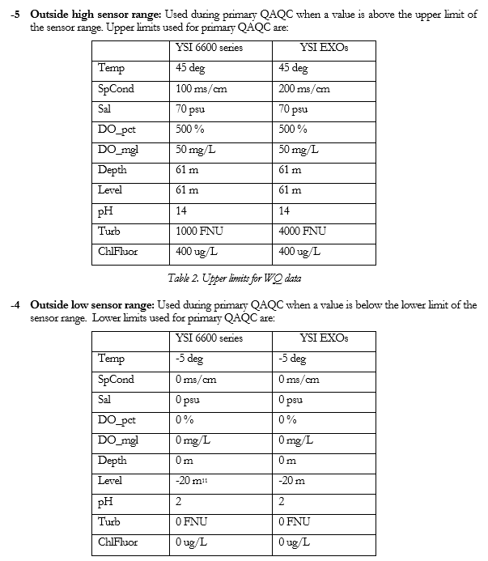

Low sensor range for Level is an arbitrarily chosen negative value and is not a sensor specification.
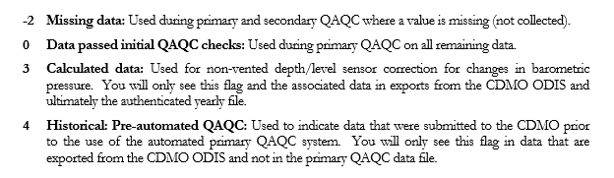

Raw data submission for primary QAQC

Considerations before submitting to the CDMO:

Ensure that the raw file does not contain any pre- or post-deployment data before uploading as these records may overwrite other existing records.

Ensure that the file to be imported has a header and a units row, otherwise the upload process will be aborted. Ensure that the file is in comma delimited format (a comma-separated-value or CSV file where commas separate the values). For the station name, use the station code found on the Florida Aquatic Preserves web page, for example ‘BBSKB’. Ensure that the time units label is ‘M/D/Y’, this will be column assigned to ‘DateTimeStamp’ in a later step and the imported timestamp values may follow a Y/M/D format which will be changed to M/D/Y in the export.

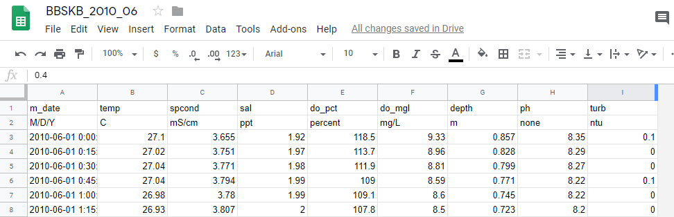
Figure 1. Example CSV file with header and unit lines

1) Login or go to the registration page to setup a user id and password to login at http://cdmo.baruch.sc.edu/nonswmp/

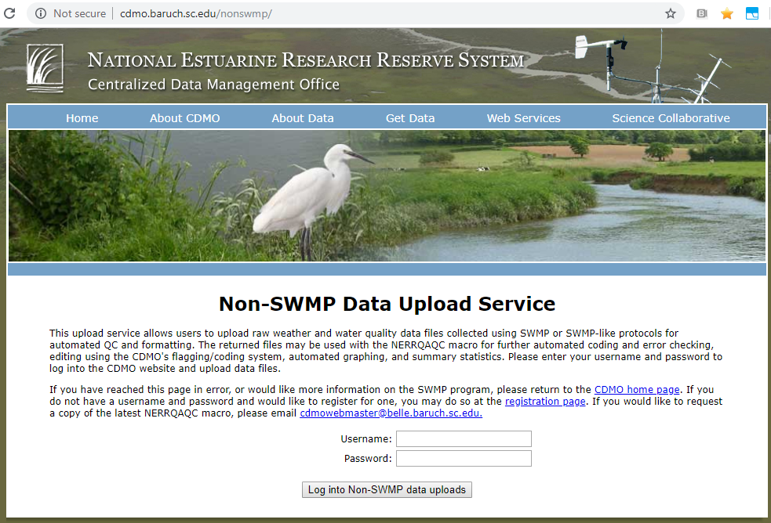

Figure 2. Log into CDMO

2) Enter the station code. Designate water quality data to upload by choosing the WQ radio button. Enter a valid email address so that the primary QAQC’d data file can be emailed to you. You will use this file to conduct secondary QAQC using the tools provided by the CDMO. Click on the Continue button to proceed.

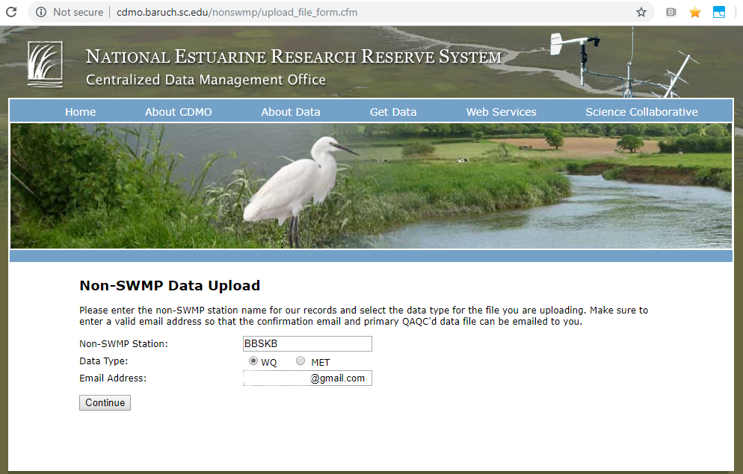
Figure 3. Specify type of data to upload and return email

3) Specify the file to upload to the CDMO. Select the sonde type by choosing either EXO or 6600. This allows the upload function to account for difference in raw file formatting and applies the appropriate sensor range checks. Use the Browse button to locate the file to upload on your computer. Click on the Upload button to proceed.
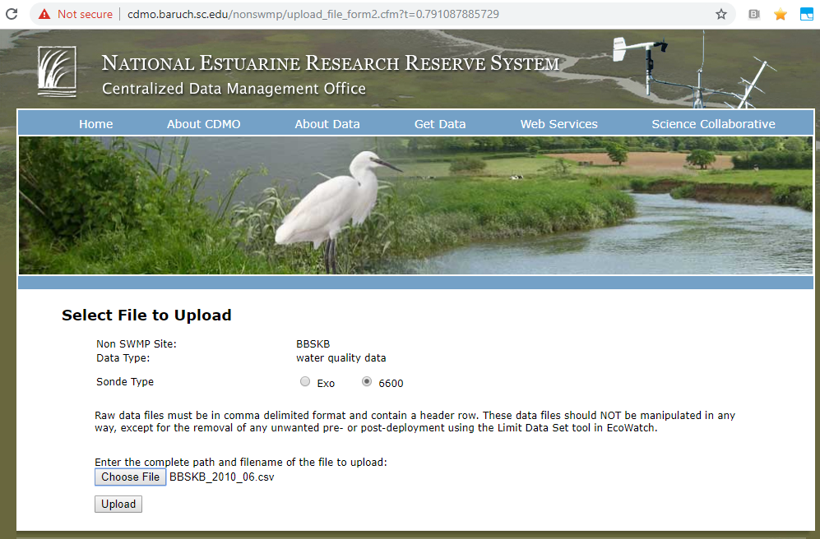
Figure 4. Specify file to upload

4) The file will now be checked against the CDMO database of required SWMP parameters and header information will be extracted. Troubleshooting: If the file is not in comma delimited format or does not have the right header information, such as a units row, you will receive a “Process aborted” alert. If you need assistance, contact the CDMO support team at cdmosupport@belle.baruch.sc.edu.

5) You will now be asked to verify the parameters in the data file. For the time parameter be sure to select ‘DateTimeStamp’. If there are any parameter headers that do not match the CDMO database of required SWMP parameters, you will have an opportunity to identify those parameters now. (Sometimes different datasonde software outputs different headers for the same parameter). Only the designated SWMP parameters will be processed. All Non Standard Parameter data will be returned to you in the primary QAQC’d data file to assist with a more thorough secondary QAQC.
a. Required WQ SWMP parameters include: Water temperature, specific conductivity, salinity, DO percent saturation, DO concentration, depth or level, pH and turbidity Optional WQ SWMP supported parameters include: Chlorophyll fluorescence
b. Use the drop down list to match up any unidentified parameters in the file with the correct table reference. If it is a non-required SWMP parameter, such as diagnostic information, make sure Non Standard Parameter is chosen.
c. If the file contains dissolved oxygen data from both the rapid-pulse and ROX DO sensors, you must choose Non Standard Parameter for one set of DO parameters.
d. If the file contains an optional SWMP supported parameter, such as chlorophyll fluorescence, you may choose to designate it as a Non Standard Parameter so that it will not be processed, or you may choose the ChlFluor table reference from the drop down list for processing.

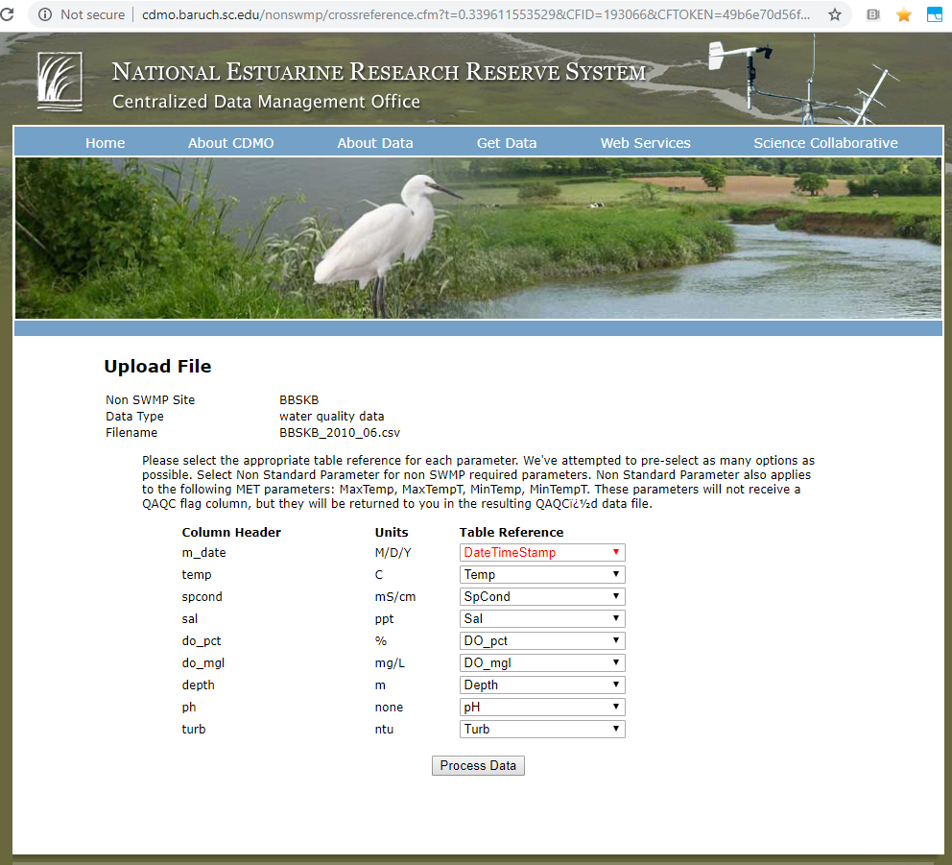

Figure 5. Verify parameter names

e. Once all the parameters have been correctly identified, click the Process Data button for the data to be imported into the CDMO database.

6) The following actions occur as the data are processed:
a. The date and times are corrected to read exactly on the quarter hour. This eliminates the appearance of duplicate data.
b. Any data previously existing in the database for the same date and time record are deleted.
c. As the data go through primary QAQC, each value is checked to ensure that it is not outside of sensor range or missing and a QAQC flag is inserted into the parameter flag column.
d. Flag columns are inserted after every required or optional SWMP parameter and given a header preceded by a F_. An F_Record column is inserted before the parameter columns to allow codes that apply to the entire record.
e. Data in the first record of each deployment are coded with (CND) to indicate the beginning of a new deployment.

7) Once the raw data have been successfully uploaded to the CDMO, you will be notified of the number of records that were inserted into the CDMO database. Click the Upload more files button to upload additional files to the CDMO.
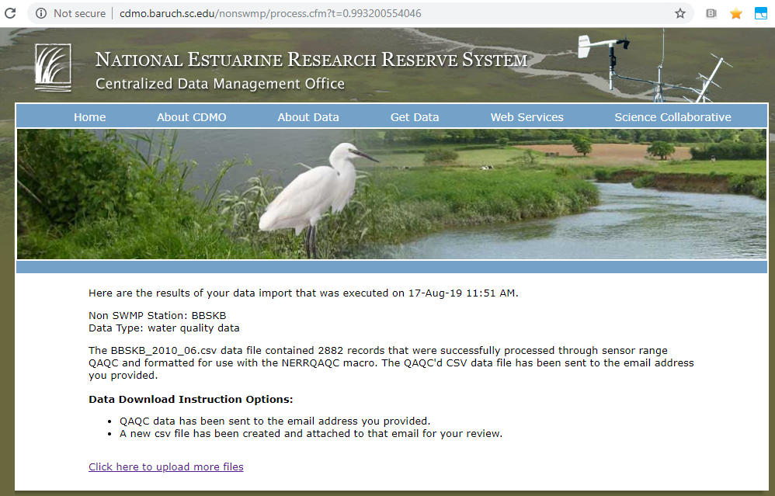
Figure 6. Upload complete

8) The primary QAQC’d file will now be emailed to you. Email delivery time should occur within a few minutes of a successful data submission. You will use this file to conduct secondary QAQC. Note that the primary QAQC’d file has been renamed with a “QC” appended to the end of the filename. a. Open the email and save the attached data file to a folder that specifically contains primary QAQC data from the CDMO.

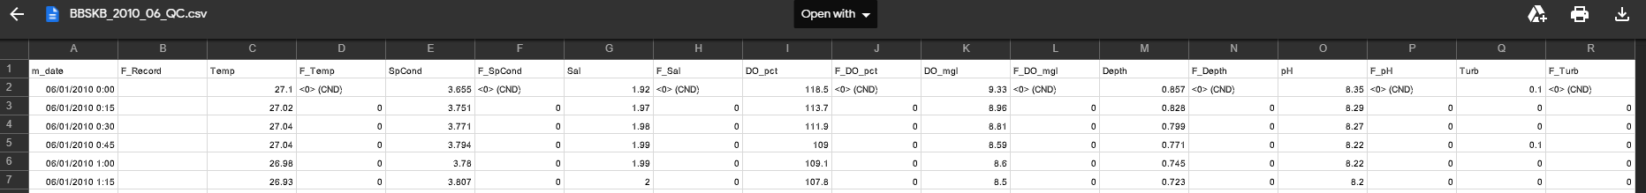
Figure 7. Processed data attached to sent email

9) The primary QAQC’d file is now ready for secondary QAQC. Secondary QAQC can be done using the NERRQAQC Excel macro provided by the CDMO in combination with the documentation listed in CDMOManual6.6.pdf document.

