Sensor Inventory Spreadsheet

The purpose of the sensor inventory spreadsheet is to provide a method of tracking sonde/sensor equipment, their dates of use and notes regarding sonde/sensor usage.

The spreadsheet is divided between two sheets, one for sondes and one for sensors.

For sondes, the Nickname field should be unique to each sonde as it is used to associate sensors with a unique sonde.

The unique identifying field for a sensor is its serial number.

Both sonde and sensor have the following fields which need be filled in only once at their associated beginning sonde/sensor record - Serial Number, Type, Model and Manufacture Year

There are 2 date fields which are populated with the start(Date Active) and end(Date Inactive) dates of a sonde/sensor deployment. The third date field - Date Retired refers the final date after which the sonde/sensor is no longer used. Date formats should be YYYY/MM/DD. The ‘Notes’ field can be populated with any associated free-form text notes for the start or end of the deployment. Some example sonde/sensor entries might be like below:

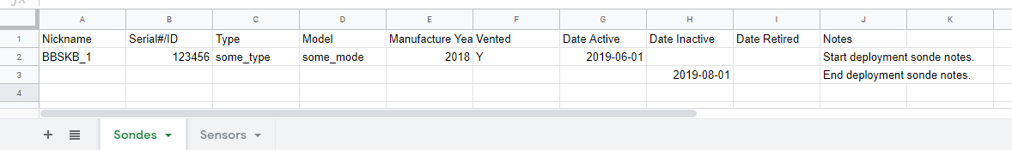
Figure 1: Example Sonde records.

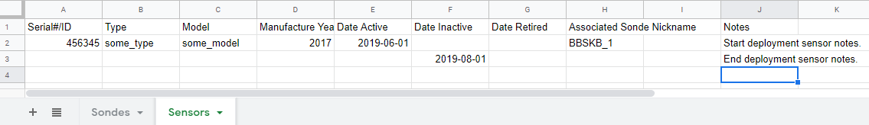
Figure 2: Example Sensor records.

