Charlotte Harbor Aquatic Preserves (CHAP)
Water Quality Metadata Report
January - December 2015
Latest Update: 01/11/2019
Note: This is a provisional metadata document; it has not been authenticated as of its download date. Contents of this document are subject to change throughout the QAQC process and it should not be considered a final record of data documentation until that process is complete. Contact the Aquatic Preserve Office (Melynda.A.Brown@dep.state.fl.us) with any additional questions.

I. Data Set and Research Descriptors

- Principal investigator & contact persons:

Principal Investigator:

Melynda A. Brown, Aquatic Preserve Manager
12301 Burnt Store Road
Punta Gorda, FL 33955
(941) 575-5861
Melynda.A.Brown@dep.state.fl.us

Other Contact Persons:
Mary McMurray, Environmental Specialist I
12301 Burnt Store Road
Punta Gorda, FL 33955
(941)-575-5861
Mary.McMurray@dep.state.fl.us

- Entry verification:

[This section is currently incomplete]

Beginning in July 2018, data underwent a two-step (primary and secondary) Quality Assurance/Quality Control (QA/QC) procedure as outlined in the NERRS CDMO Data Management Manual Version 6.6 (http://cdmo.baruch.sc.edu/request-manuals/).

The primary QA/QC process was performed by the CDMO and involved inserting flag columns into the data files for each water quality parameter, creating a flag record column, and creating an automated process that applied standardized flags to data if the values were outside sensor specifications as determined by YSI, the instrument manufacturer. Yearly data files that completed the primary QA/QC process were returned to FCO staff for secondary QA/QC. Data were evaluated, and standardized flags and codes were applied to individual data points by insertion into the flag columns using the CDMO’s NERRQAQC Excel macro to provide further documentation of the data. Data files were then returned to the CDMO for ingestion into the Florida Aquatic Preserves database as provisional data. For more information on QA/QC flags and codes, see Sections 11 and 12.
- Research objectives:

In September 2005, two permanent monitoring stations, in north and south Matlacha Pass, were established and equipped with continuous water-quality-data collection equipment. A third site was added near the Matlacha bridge in 2009. These sites were selected to monitor the extent of the tidal node in Matlacha Pass Aquatic Preserve in addition to the tidal influence of the Caloosahatchee River, Charlotte Harbor and runoff from adjacent Cape Coral and Matlacha.

- Research Methods:

All three water quality stations take readings every 15 minutes for DOmg/L, DO%, Salinity, Sp. Conductivity (ms/cm), Turbidity NTU, Depth (m), Temperature (C) and pH at 0.5 meters off the bottom. Monthly grab samples are taken 0.5m off the bottom for red tide, chlorophyll a, total nitrogen and total phosphorous.

- Site location and character:

The Charlotte Harbor Aquatic Preserves encompass five aquatic preserves and protect more than 180,000 acres, set aside so that their aesthetic, biologic and scientific values endure for the enjoyment of future generations.

Aquatic preserves staff and volunteers routinely monitor water quality and natural resources in the bay, such as seagrasses and nesting birds; provide educational materials, scientific data and provide outreach presentations upon request; and work with the Friends of Charlotte Harbor Aquatic Preserves to conduct water quality monitoring and other aspects of management. Eco-ventures, including snorkeling and nature boat tours, are offered to provide hands-on experiences in the aquatic preserves.

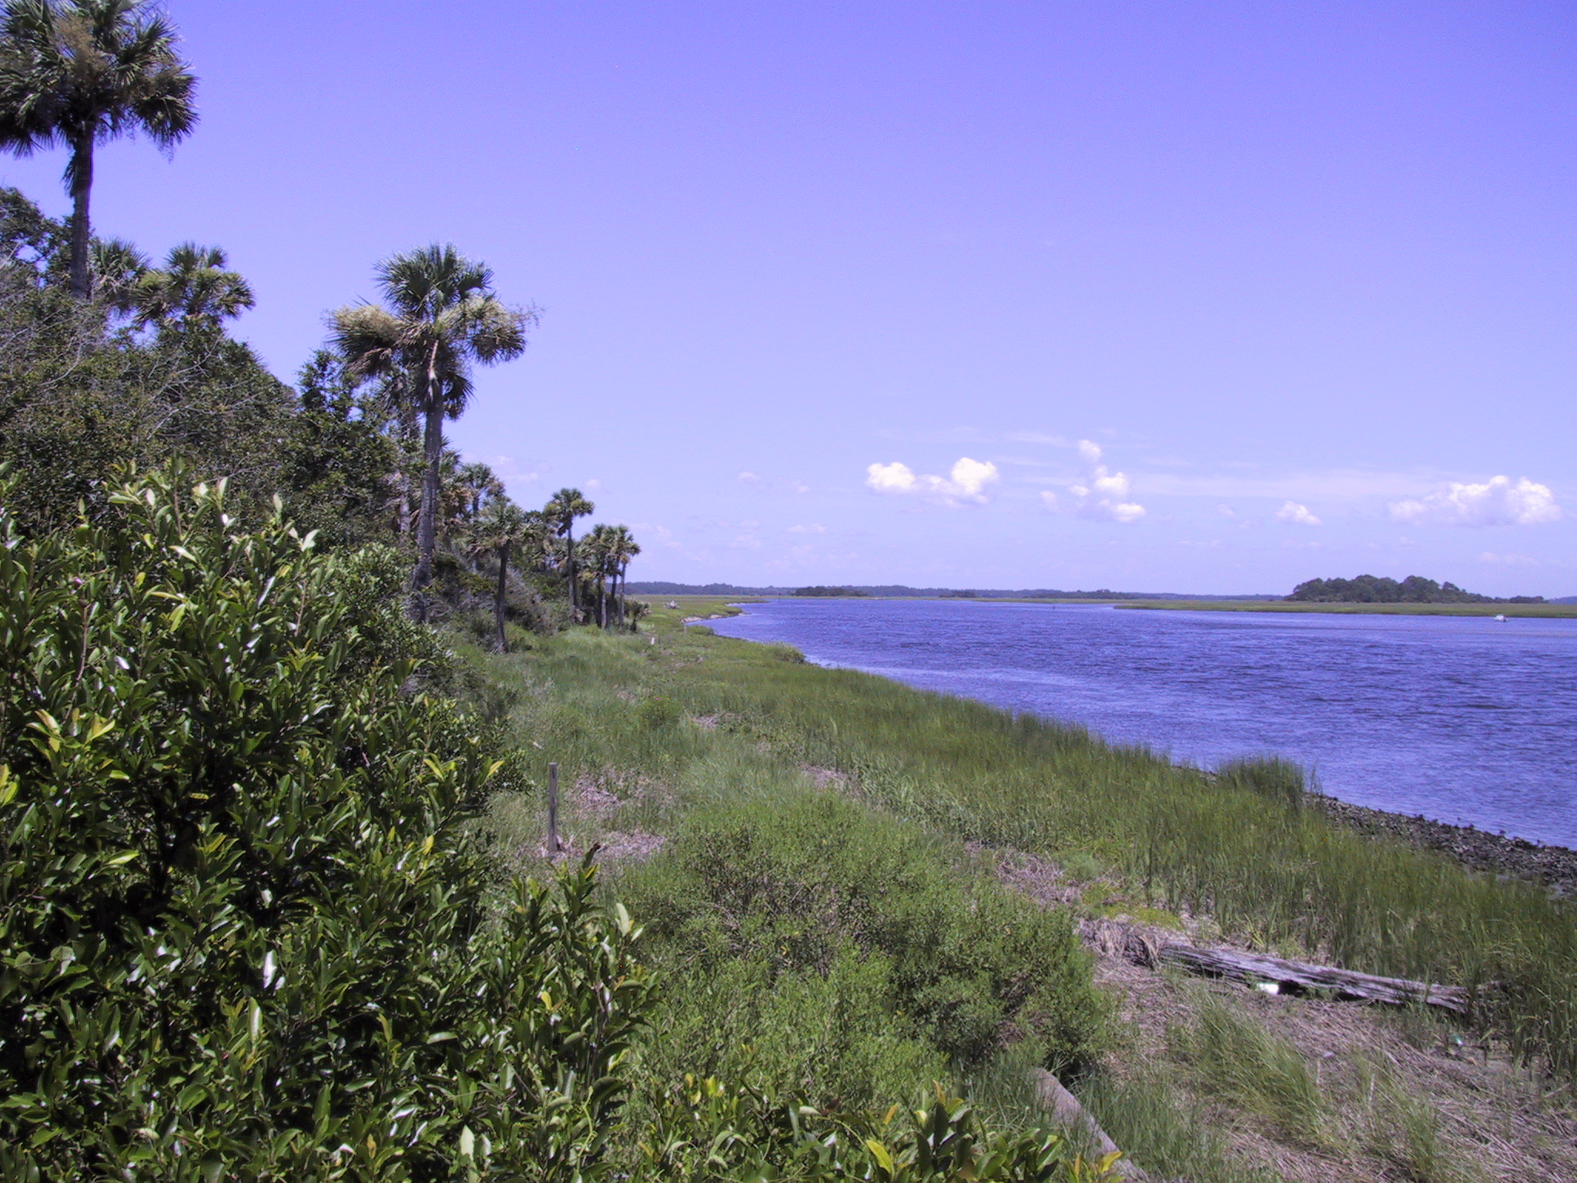
Station description:

Charlotte Harbor Aquatic Preserves manages three continuous datasonde stations in Matlacha Pass Aquatic Preserve. MP1A in the north and MP2B in the south were set up in 2005, and MP3C just south of the Matlacha bridge was set up in 2009.

Station timeline:

Station Code | Station Name | Location | Active Dates | Reason Decommissioned | Notes
MP1A | MP1A | 26.667800°N, -82.094600°W | 10/2005 - Present | N/A | N/A
MP2B | MP2B | 26.562700°N, -82.070400°W | 9/2005 - Present | N/A | N/A
MP3C | MP3C | 26.628800°N, -82.067400°W | 3/2009 - Present | N/A | N/A

- Data collection period:

Data collection information is currently unavailable.

- Distribution:

Considerable effort has been made to ensure the accuracy of the information provided and meet quality assurance guidelines used by the Florida’s Department of Environmental Protection. Please note that the included data are estimates of actual conditions subject to improvements in accuracy and precision of field methods over time as well as infrequencies in sampling duration, rendering data in some instances, to be unsuitable for temporal or spatial comparisons. As a result, the user is responsible for interpretations based on supplied data.

Neither the State of Florida nor the Florida Department of Environmental Protection makes any warranty, expressed or implied, including the warranties of merchantability and fitness for a particular purpose arising out of the use or inability to use the data, or assumes any legal liability or responsibility for the accuracy, completeness, or usefulness of any information, apparatus, product, or process disclosed, or represents that its use would not infringe privately owned rights.

The PI retains the right to be fully credited for having collected and processed the data. Following academic courtesy standards, Charlotte Harbor Aquatic Preserves will be contacted and fully acknowledged in any subsequent publications in which any part of the data are used. The user bears all responsibility for its subsequent use/misuse in any further analyses or comparisons.

- Associated researchers and projects:

Associated researchers and projects information are currently unavailable.

II. Physical Structure Descriptors

- Sensor specifications:

Table 2. YSI 6600 EDS data sonde

Parameter: Temperature
Units: Celsius (C)
Sensor Type: Thermistor
Model #: 6560
Range: -5 to 45 °C
Accuracy: +/-0.15 °C
Resolution: 0.01 °C

Parameter: Conductivity
Units: milli-Siemens per cm (mS/cm)
Sensor Type: 4-electrode cell with autoranging
Model #: 6560
Range: 0 to 100 mS/cm
Accuracy: +/-0.5% of reading + 0.001 mS/cm
Resolution: 0.001 mS/cm to 0.1 mS/cm (range dependent)
Parameter: Salinity
Units: parts per thousand (ppt)
Sensor Type: Calculated from conductivity and temperature
Range: 0 to 70 ppt
Accuracy: +/- 1.0% of reading or 0.1 ppt, whichever is greater
Resolution: 0.01 ppt

Parameter: Dissolved Oxygen % saturation
Units: percent air saturation (%)
Sensor Type: Rapid Pulse – Clark type, polarographic
Model #: 6562
Range: 0 to 500 % air saturation
Accuracy: 0-200 % air saturation, +/- 2 % of the reading or 2 % air saturation, whichever is greater; 200-500 % air saturation, +/- 6 % of the reading
Resolution: 0.1 % air saturation

Parameter: Dissolved Oxygen mg/L (Calculated from % air saturation, temperature and salinity)
Units: milligrams per Liter (mg/L)
Sensor Type: Rapid Pulse – Clark type, polarographic
Model #: 6562
Range: 0 to 50 mg/L
Accuracy: 0 to 20 mg/L, +/- 2 % of the reading or 0.2 mg/L, whichever is greater; 20 to 50 mg/L, +/- 6 % of the reading
Resolution: 0.01 mg/L

Parameter: Non-Vented Level – Shallow (Depth)
Units: feet or meters (ft or m)
Sensor Type: Stainless steel strain gauge
Range: 0 to 30 ft (9.1 m)
Accuracy: +/- 0.06 ft (0.018 m)
Resolution: 0.001 ft (0.001 m)

Parameter: pH (specify whether EDS probe or not)
Units: units
Sensor Type: Glass combination electrode
Model #: 6561
Range: 0 to 14 units
Accuracy: +/- 0.2 units
Resolution: 0.01 units

Parameter: Turbidity
Units: nephelometric turbidity units (NTU)
Sensor Type: Optical, 90 ° scatter, with mechanical cleaning
Model #: 6136
Range: 0 to 1000 NTU
Accuracy: +/- 5 % reading or 2 NTU (whichever is greater)
Resolution: 0.1 NTU

Dissolved Oxygen Qualifier: The reliability of the dissolved oxygen (DO) data after 96 hours post-deployment for non-EDS (Extended Deployment System) data sondes may be problematic due to fouling which forms on the DO probe membrane during some deployments (Wenner et al. 2001). Many Aquatic Preserves have upgraded to YSI 6600 EDS data sondes, which increase DO accuracy and longevity by reducing the environmental effects of fouling. The user is therefore advised to consult the metadata and to exercise caution when utilizing the DO data beyond the initial 96-hour time period. However, this potential drift is not always problematic for some uses of the data (e.g., periodicity analysis). It should be noted that the amount of fouling is site specific and that not all data are affected. The Principal Investigator at should be contacted concerning the reliability of the DO data because of the site and seasonal variation in the fouling of the DO sensor.

Depth Qualifier: The water quality monitoring program utilizes YSI data sondes that can be equipped with either depth or water level sensors. Both sensors measure water depth, but by convention, level sensors refer to atmospherically vented measurements and depth refers to non-vented measurements. Standard calibration protocols for the non-vented sensor use the atmosphere pressure at the time of calibration. Therefore, changes in atmospheric pressure between calibrations appear as changes in water depth. The error is equal to approximately 1.03 cm for every 1millibar change in atmospheric pressure. This error is eliminated for level sensors because they are vented to the atmosphere throughout the deployment time interval. If proper atmospheric pressure data is available, non-vented sensor depth measurements can be corrected for deployments between calibrations. Readings for both vented and non-vented sensors are automatically compensated for water density changes due to variations in temperature and salinity. The Principal Investigator should be contacted in order to obtain information regarding atmospheric pressure data availability. All data sondes used at all 6600 sites in 2006 were non-vented models.

Salinity Units Qualifier: 6600 series sondes report salinity in parts per thousand (ppt) units and the EXO sondes report in practical salinity units (psu). These units are essentially the same and for the AP water quality program purposes are understood to be equivalent, however psu is considered the more appropriate designation. Moving forward the AP program will assign psu salinity units for all data regardless of sonde type.

Turbidity Qualifier: 6600 series sondes report turbidity in nephelometric turbidity units (NTU) and the EXO sondes use formazin nephelometric units (FNU). These units are essentially the same but indicate a difference in sensor methodology, for AP water quality program purposes they will be considered equivalent. Moving forward, the AP program will use FNU/NTU as the designated units for all turbidity data regardless of sonde type. If turbidity units and sensor methodology are of concern, please see the Sensor Specifications portion of the metadata.

- Coded variable definitions:

Site definitions:

Sampling Station: | Sampling Site Code: | Station Code:
MP1A | MP1A | MP1A
MP2B | MP2B | MP2B
MP3C | MP3C | MP3C

- QAQC flag definitions:

QAQC flags provide documentation of the data and are applied to individual data points by insertion into the parameter’s associated flag column (header preceded by an F_). During primary automated QAQC (performed by the CDMO), -5, -4, and -2 flags are applied automatically to indicate data that is missing and above or below sensor range. All remaining data are then flagged 0, passing initial QAQC checks. During secondary and tertiary QAQC 1, -3, and 5 flags may be used to note data as suspect, rejected due to QAQC, or corrected.

-5 Outside High Sensor Range
-4 Outside Low Sensor Range
-3 Data Rejected due to QAQC
-2 Missing Data
-1 Optional SWMP Supported Parameter
0 Data Passed Initial QAQC Checks
1 Suspect Data
2 Open - reserved for later flag
3 Calculated data: non-vented depth/level sensor correction for changes in barometric pressure
4 Historical Data: Pre-Auto QAQC
5 Corrected Data

- QAQC code definitions:

QAQC codes are used in conjunction with QAQC flags to provide further documentation of the data and are also applied by insertion into the associated flag column. There are three (3) different code categories, general, sensor, and comment. General errors document general problems with the deployment or YSI datasonde, sensor errors are sensor specific, and comment codes are used to further document conditions or a problem with the data. Only one general or sensor error and one comment code can be applied to a particular data point, but some comment codes (marked with an * below) can be applied to the entire record in the F_Record column.

General Errors
GIC No instrument deployed due to ice
GIM Instrument malfunction
GIT Instrument recording error; recovered telemetry data
GMC No instrument deployed due to maintenance/calibration
GNF Deployment tube clogged / no flow
GOW Out of water event
GPF Power failure / low battery
GQR Data rejected due to QA/QC checks
GSM See metadata

Corrected Depth/Level Data Codes
GCC Calculated with data that were corrected during QA/QC
GCM Calculated value could not be determined due to missing data
GCR Calculated value could not be determined due to rejected data
GCS Calculated value suspect due to questionable data
GCU Calculated value could not be determined due to unavailable data

Sensor Errors
SBO Blocked optic
SCF Conductivity sensor failure
SCS Chlorophyll spike
SDF Depth port frozen
SDG Suspect due to sensor diagnostics
SDO DO suspect
SDP DO membrane puncture
SIC Incorrect calibration / contaminated standard
SNV Negative value
SOW Sensor out of water
SPC Post calibration out of range
SQR Data rejected due to QAQC checks
SSD Sensor drift
SSM Sensor malfunction
SSR Sensor removed / not deployed
STF Catastrophic temperature sensor failure
STS Turbidity spike
SWM Wiper malfunction / loss

Comments
CAB* Algal bloom
CAF Acceptable calibration/accuracy error of sensor
CAP Depth sensor in water, affected by atmospheric pressure
CBF Biofouling
CCU Cause unknown
CDA* DO hypoxia (<3 mg/L)
CDB* Disturbed bottom
CDF Data appear to fit conditions
CFK* Fish kill
CIP* Surface ice present at sample station
CLT* Low tide
CMC* In field maintenance/cleaning
CMD* Mud in probe guard
CND New deployment begins
CRE* Significant rain event
CSM* See metadata
CTS Turbidity spike
CVT* Possible vandalism/tampering
CWD* Data collected at wrong depth
CWE* Significant weather event

- Post deployment information:

Post deployment information is currently unavailable.

- Other remarks/notes:

Missing Data

Data are missing due to equipment or associated specific probes not being deployed, equipment failure, time of maintenance or calibration of equipment, or repair/replacement of a sampling station platform. Any NANs in the dataset stand for “not a number” and are the result of low power, disconnected wires, or out of range readings. If additional information on missing data is needed, contact the Principal Investigator.

Rejected Data:

Obvious outliers, data associated with probe malfunction, and/or calibration (both pre and post) problems are rejected as specified below. For more details about rejected data, contact the Principal Investigator.

See Metadata “CSM” “GSM” Notes/Comments from Data Files

Anomalous/Suspect data:

Note #1: Slight shifts in data are sometimes correlated with sonde exchanges. These shifts are most noticeable in pH, specific conductivity, salinity, DO% and DO conc, and may be related to sensor drift (e.g., due to fouling) and/or calibration/performance differences between sondes.

Note #2: Turbidity “outliers” (i.e., values that are negative or greater than 1000 NTU for 6600 series sondes and 4000 NTU for EXO series sondes) were not deleted from the monthly records. Readings greater than 1000 NTU for 6600 series sondes and 4000 NTU for EXO series sondes are considered out of range and are rejected. They have been left in the database to provide users with a complete dataset and to allow true visual representation of the data in graphs. Negative turbidity values occur throughout the year at all four sites. Some of these negative values are within the accuracy range of the sensor (+/- 2.0 %) and, therefore, were not removed from the dataset. They were marked suspect with the CAF code.

Note #3: Turbidity data is subject to single and clusters of spikes that occur in the beginning and middle of deployments. Turbidity values that fall between 500 and 1000 are not specifically indicated as suspect data, but possibly could be interpreted as suspect. Turbidity spikes may be associated with wiper malfunction but mostly the reason is unknown. Data users should exercise caution when interpreting turbidity data that fall within this range.

Acknowledgement: The data included with this document were collected by the staff of the Florida Department of Environmental Protection. Any products derived from these data should clearly acknowledge this source (please use the attached logos below). This recognition is important for ensuring that these long-term monitoring programs continue to receive the necessary political and financial support.

